TreeSim
Project Description

Submitted to:

Prof. Ma. Rowena C. Solamo
Faculty Member
Department of Computer Science
College of Engineering
University of the Philippines, Diliman

Submitted by:
Albano, Romeo Senen D.
Endaya, Jeynald Jeyromme L.
Quiñones, Yzabel Iesa M.

In partial fulfillment of Academic Requirements
for the course
CS 191 Software Engineering I
of the
1st Semester, AY 2014-2015

Unique Reference:
The documents are stored in the https://github.com/jjlendaya/CS191pinkPlastiCS
File Name: “Project Description Document.odt”
File reference in GitHub: https://github.com/jjlendaya/CS191pinkPlastiCS/blob/master/Requirements/Project%20Description%20Document.odt

Document Purpose:
This document aims to establish the goals of this project through its description as well as to specify the project boundaries and scope.

Target Audience:
This document is intended for the clients (#080419 Android) of Pink PlastiCS for the TreeSim project.

Revision Control:
Revision Date | Person Responsible | Version  Number | Modification
08/23/2014 | Albano, Romeo Senen  Endaya, Jeynald  Quiñones, Yzabel | 1.0 | Initial Document;

Project Title: TreeSim

Description: TreeSim (Tree Simulator) is an application intended for the Android OS mobile platform that’s especially built for Computer Science students taking undergraduate courses. This application will contain study modules for important topics in the curriculum, such as trees, which aim to further understanding by giving supplementary interactive simulations. Through this application, students can easily find demonstrations of common algorithms, simulators of data structures, and other interactive models of many theoretical concepts. A recommended use of this application would be in a classroom setting where both students and teachers can use it as demonstrations for study.

Context Diagram:

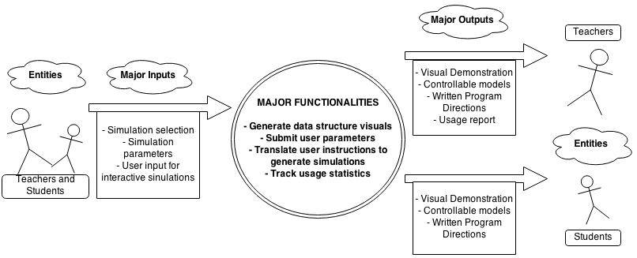

Place here the Context Diagram. Make sure that the diagram is grouped as one and text does not wrap around the diagram.

Entities:

Student | Students are the main target users of the application. The intention of the application is to allow students to use and view the interactive simulations in order to further their learning.
Teachers | Teachers can also make use of the application in a classroom setting by using it to give visual demonstrations to students or using the usage statistics functionality to more easily understand where students have trouble in the subject.

Major Inputs:

Input by Students and Teachers

Students and teachers as entities give the same kinds of input to the program.

Simulation Selection | As the users navigate through the system, they will encounter lists of simulations available to them. This input basically refers to their choice of simulations to view. Simulations come in two types, which can either be Modifiable Computer Generated Imagery (MCGI) or Modifiable Computer Generated Videos (MCGV).
Simulation Parameters | For MCGV simulations, users will be allowed to give certain parameters that will change basic elements of the simulation. Simulations like these are more like videos. These simply ask for parameter settings at the beginning and then run until their end.
Interactive Simulation User Input | For the MCGI simulations, users will constantly be able to send instructions that will manipulate and control the simulation. Simulations like these act more like “builders” for a data structure or concept.

Major Outputs:

Visual Demonstrations | For both types of simulations, the users will enable to view the step-by-step visual demonstration of their chosen simulation after giving the necessary parameters.
Controllable Visual Models | The main feature of MCGI simulations is that it is customizable by the user. Users will be able to create, utilize, and manipulate the tree using builders to properly visualize the process behind each simulation.
Written Program Directions | While the visual demonstration of the chosen simulation is running, the user can also see an accompanying written directions of what is currently happening or the rules on that particular theory.
Usage Report | This is a report on how the user makes use of the application, detailing information such as which simulations are used most frequently. This can be used to aid teachers in tracking which topics students find most difficult.

Major Functionalities:

Generate Data Structure Visuals | The system is responsible for generating the actual visuals that will be displayed to the user. Because the user can give their initial parameters that modify the simulations, the system must generate the visuals from scratch.
Submit User Parameters | The system is able to accept parameter from the user depending on the simulation that they have chosen.
Translate Parameters to Simulations | The system will take into account the parameters that the user has set in generating the visuals. In the case of MCGI, the system will constantly be taking input from the user and processing this to find out what imagery to generate.
Track Usage Statistics | As an additional functionality, the system will also track how the students make use of the program.

